Justin Casteel  
June 12, 2016

Project 2 - Written Document

UML Diagram - Attached as .gif image in a separate file.

My approach going into this project was to keep the interface as simple, readable, and understandable to the user as possible. This also includes the error messages, I wanted the user to know right away without getting frustrated what was going on and what they needed to change to use the program successfully. I documented each and every method and functions in my program through comments to easily be read by someone else looking at my code. I kept my code readable and organized with good indentation practice so errors could be found easily and also made the code easy to read and understand.

I learned a lot in this project that I didn’t know before, especially with action listeners and buttons. It is great that the java developers have made such an easy to use system, having a separate action listener for each button in your program on what that button should do. I also learned about types of error boxes and symbols you can use inside the popup boxes, it doesn’t just have to be the default settings, you can change it up a lot and really make your program stand out to the user.

Test Plan:

The user interface presented to the user at program execution:

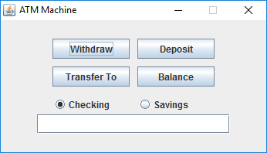

The error box shown to the user when trying to withdraw or deposit any amount that isn’t in increments of $20.00. This same error message shows when trying to transfer funds from one account to the other and not using $20.00 increments.

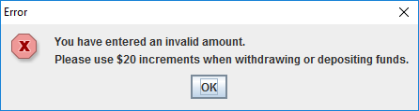

Shows the balance of the currently selected account:

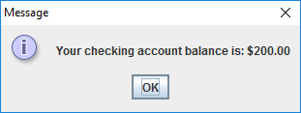

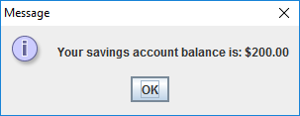

The user is able to type numbers in increments of 20 in the text field below, for example:

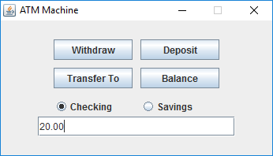

Transferring from one account to another will have a success box as follows for each account, using this in $20.00 increments is not needed:

